Tracking process modul pak aris

# Proses

## Praktikum 1

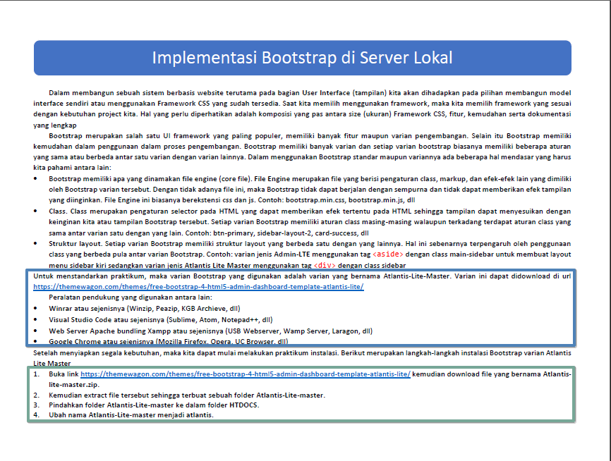

gambar 1

maksud dari folder **htdocs.** Kita kan sudah install **xampp**, atau **mamp**, jadi begini htdocs itu didalam folder **C:\xampp\htdocs**\ kalau untuk **mamp** itu juga sama. Beda cerita kalau pakai **laragon** itu ada didalam folder **C:\laragon\www\**.

Penempatan **atlantis-lite** ada di dalam folder tersebut

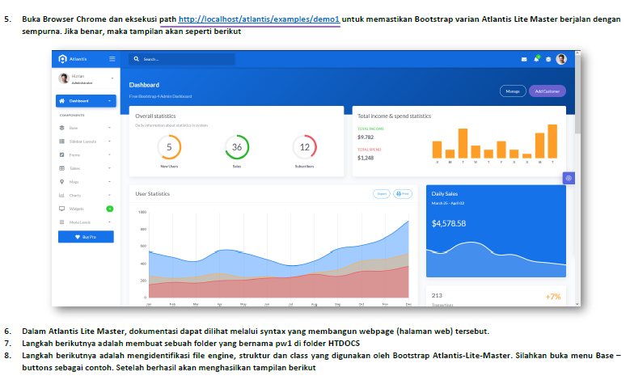

gambar 2

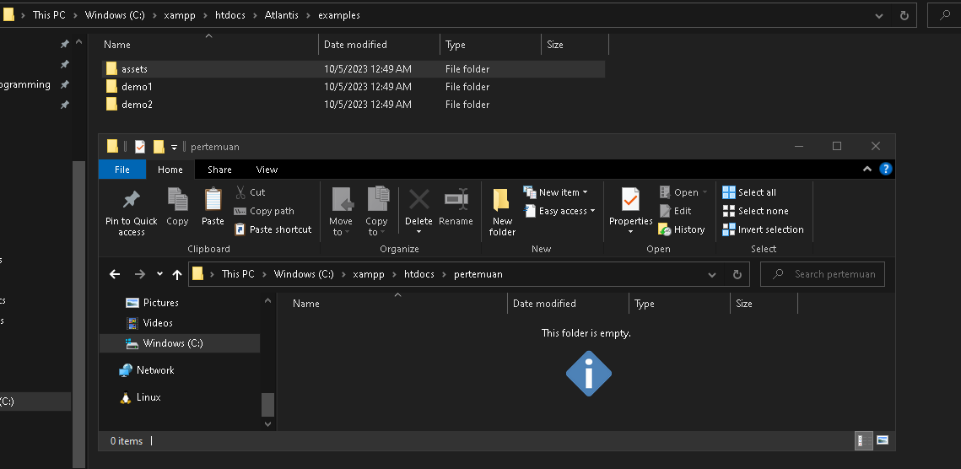

gambar 3

folder assets kamu copy terus masukan ke pertemuan

masuk ke link ini <http://localhost:8080/Atlantis/examples/demo1/components/buttons.html> atlantis

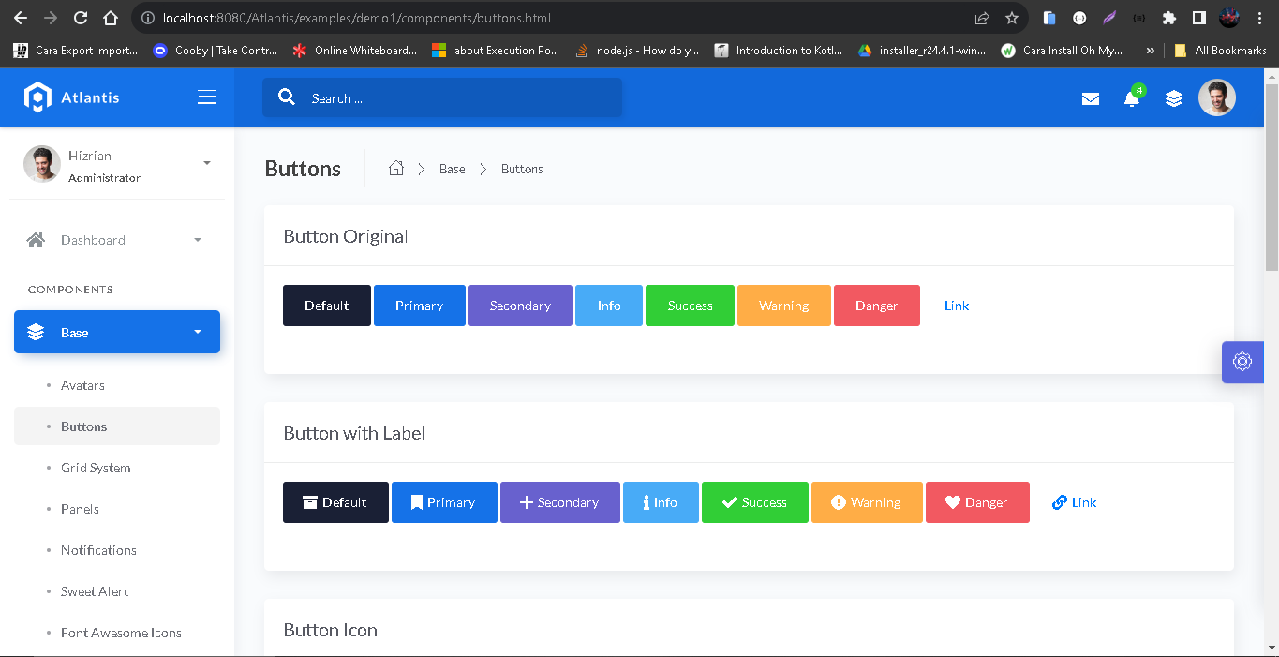

gambar 4

membuat file index.php

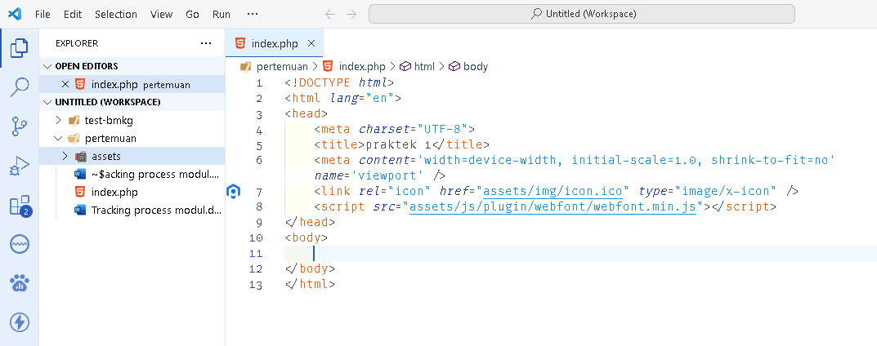

gambar 5

kode ini di masukan di bawahnya

.. kode disembunyikan ..

        WebFont.load**(**{ **google:** {**"families":[**"Lato:300,400,700,900"**]**}, **custom:** {**"families":[** "Flaticon", "Font Awesome 5 Solid", "Font Awesome 5 Regular", "Font Awesome 5 Brands", "simple-line-icons"**]**, **urls:** **[**'assets/css/fonts.min.css'**]** }, **active:** function() {sessionStorage.**fonts** = true;} }**)**;

    </script>

    <link *rel*="stylesheet" *href*="assets/css/bootstrap.min.css">

    <link *rel*="stylesheet" *href*="assets/css/atlantis.min.css">

    <script *src*="assets/js/core/jquery.3.2.1.min.js"></script>

    <script *src*="assets/js/core/popper.min.js"></script>

    <script *src*="assets/js/core/bootstrap.min.js"></script>

    <script *src*="assets/js/plugin/jquery-ui-1.12.1.custom/jquery-ui.min.js"></script>

    <script *src*="assets/js/plugin/jquery-ui-touch-punch/jquery.ui.touch-punch.min.js"></script>

    <script *src*="assets/js/plugin/jquery-scrollbar/jquery.scrollbar.min.js"></script>

    <script *src*="assets/js/plugin/sweetalert/sweetalert.min.js"></script>

    <script *src*="assets/js/atlantis.min.js"></script>

text box 1

Ketik syntax berikut diantara <body> dan </body>

<p *style*="width: 100%; text-align: center; margin-top: 50px;">

        <button *type*="button" *class*="btn btn-secondary btn-lg">

            Tombol Percobaan

        </button>

    </p>

text box 2

Tempatkan syntax berikut setelah </p> tapi karena saya ingin coba saya edit sedikit saya taruh diatasnya <p>

<div *class*="col-md-6 ml-auto mr-auto">

        <div *class*="card">

            <div *class*="card-header">

                <h4 *class*="card-title">Percobaan Panel</h4>

            </div>

            <div *class*="card-body">

                <ul *class*="nav nav-pills nav-secondary nav-pills-no-bd" *role*="tablist">

                    <li *class*="nav-item"> <a *class*="nav-link active" *data-toggle*="pill" *href*="#tab1" *role*="tab">Tomorrow War</a> </li>

                    <li *class*="nav-item"> <a *class*="nav-link" *data-toggle*="pill" *href*="#tab2" *role*="tab">Greyhound</a>

                    </li>

                    <li *class*="nav-item"> <a *class*="nav-link" *data-toggle*="pill" *href*="#tab3" *role*="tab">Army Of Thieves</a> </li>

                </ul>

            </div>

        </div>

    </div>

<p *style*="width: 100%; text-align: center; margin-top: 50px;">

text box 3

tempatkan syntax berikut sesudah </ul>

</ul>

                <div *class*="tab-content mt-2 mb-3">

                    <div *class*="tab-pane fade show active" *id*="tab1" *role*="tabpanel">

                        <p *style*="color: red">A family man is drafted to fight in a future war where the fate of humanity relies on his

                            ability to confront the past</p>

                    </div>

                    <div *class*="tab-pane fade" *id*="tab2" *role*="tabpanel">

                        <p *style*="color: green">Several months after the U.S. entry into World War II, an inexperienced U.S. Navy

                            commander must lead an Allied convoy being stalked by a German submarine wolf pack</p>

                    </div>

                    <div *class*="tab-pane fade" *id*="tab3" *role*="tabpanel">

                        <p *style*="color: blue">A prequel, set before the events of Army of the Dead, which focuses on German safecracker

                            Ludwig Dieter leading a group of aspiring thieves on a top secret heist during the early stages of the

                            zombie apocalypse</p>

                    </div>

                </div>

text box 4

hasilnya seperti ini :



gambar 6

## Praktikum 2

Implementasi modular

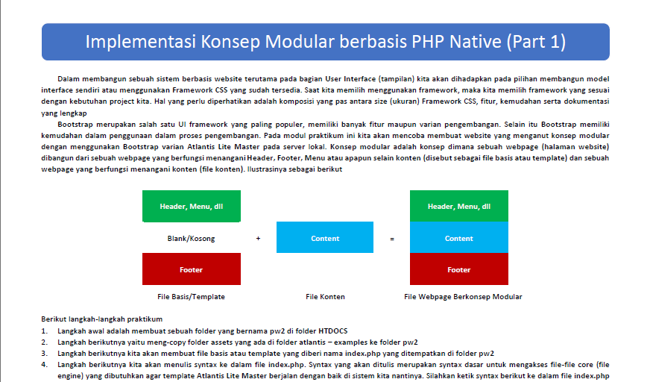

gambar 7

Karena di praktikum1 kita buat index.php. jadi kita rename aja dengan nama praktikum1.php

Jadi kita buat lagi rangkanya masih sama seperti awal.

<!DOCTYPE *html*>

<html *lang*="en">

<head>

    <meta *charset*="UTF-8">

    <title>praktek 1</title>

    <meta *content*='width=device-width, initial-scale=1.0, shrink-to-fit=no' *name*='viewport' />

    <link *rel*="icon" *href*="assets/img/icon.ico" *type*="image/x-icon" />

    <script *src*="assets/js/plugin/webfont/webfont.min.js"></script>

    <script>

        WebFont.load**(**{ **google:** {**"families":[**"Lato:300,400,700,900"**]**}, **custom:** {**"families":[** "Flaticon", "Font Awesome 5 Solid", "Font Awesome 5 Regular", "Font Awesome 5 Brands", "simple-line-icons"**]**, **urls:** **[**'assets/css/fonts.min.css'**]** }, **active:** function() {sessionStorage.**fonts** = true;} }**)**;

    </script>

    <link *rel*="stylesheet" *href*="assets/css/bootstrap.min.css">

    <link *rel*="stylesheet" *href*="assets/css/atlantis.min.css">

    <script *src*="assets/js/core/jquery.3.2.1.min.js"></script>

    <script *src*="assets/js/core/popper.min.js"></script>

    <script *src*="assets/js/core/bootstrap.min.js"></script>

    <script *src*="assets/js/plugin/jquery-ui-1.12.1.custom/jquery-ui.min.js"></script>

    <script *src*="assets/js/plugin/jquery-ui-touch-punch/jquery.ui.touch-punch.min.js"></script>

    <script *src*="assets/js/plugin/jquery-scrollbar/jquery.scrollbar.min.js"></script>

    <script *src*="assets/js/plugin/sweetalert/sweetalert.min.js"></script>

    <script *src*="assets/js/atlantis.min.js"></script>

</head>

<body>

</body>

</html>

text box 5

Tempatkan syntax berikut diantara <body> dan </body>

<div *class*="wrapper overlay-sidebar">

        <div *class*="main-header"> </div>

        <div *class*="sidebar sidebar-style-2">

        </div>

        <div *class*="main-panel">

        </div>

    </div>

text box 6

Tempatkan syntax berikut diantara <div class="main-header"> dan </div>

<div *class*="logo-header" *data-background-color*="blue2">

            </div>

            <nav *class*="navbar navbar-header navbar-expand-lg" *data-background-color*="blue2">

            </nav>

text box 7

hasilnya

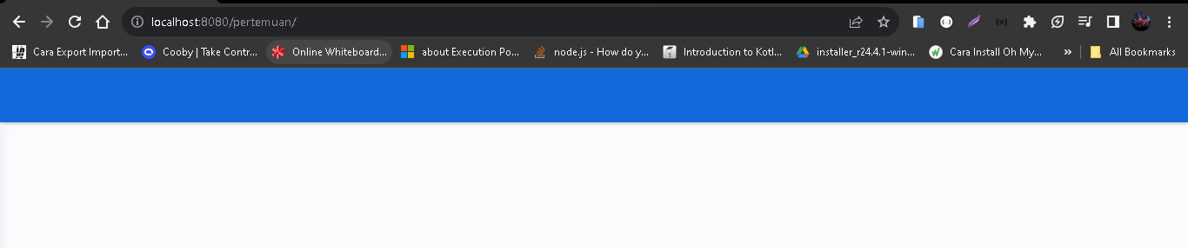

gambar 8

Tempat syntax berikut diantara <div class="logo-header" data-background-color="blue2"> dan </div>

                </a> <button *class*="navbar-toggler sidenav-toggler ml-auto" *type*="button" *data-toggle*="collapse" *data-target*="collapse" *aria-expanded*="false" *aria-label*="Toggle navigation"> <span *class*="navbar-toggler-icon"><i *class*="icon-menu"></i></span> </button> <button *class*="topbar-toggler more"><i *class*="icon-options-vertical"></i></button> <div *class*="nav-toggle"> <button *class*="btn btn-toggle sidenav-overlay-toggler"><i *class*="icon-menu"></i></button> </div>

text box 8

hasilnya

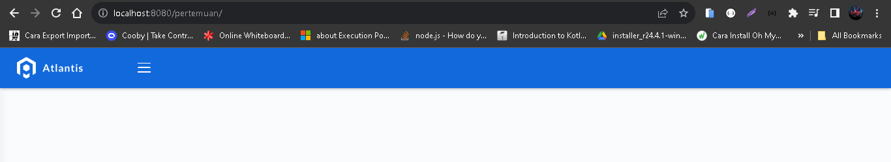

gambar 9

Tempatkan syntax berikut diantara <nav class="navbar navbar-header navbar-expand-lg" data-background-color="blue2"> dan </nav>

<div *class*="container-fluid"> <ul *class*="navbar-nav topbar-nav ml-md-auto align-items-center"> <li *class*="nav-item dropdown hidden-caret"> <a *class*="nav-link dropdown-toggle" *href*="#" *id*="messageDropdown" *role*="button" *data-toggle*="dropdown" *aria-haspopup*="true" *aria-expanded*="false"> <i *class*="fa fa-envelope"></i> </a> </li> <li *class*="nav-item dropdown hidden-caret">

                <a *class*="dropdown-toggle profile-pic" *data-toggle*="dropdown" *href*="#" *aria-expanded*="false"> <div *class*="avatar-sm"> <img *src*="assets/img/profile.jpg" *alt*="profile" *class*="avatar-img rounded-circle"> </div> </a> <ul *class*="dropdown-menu dropdown-user animated fadeIn"> <div *class*="dropdown-user-scroll scrollbar-outer"> <li> <div *class*="user-box"> <div *class*="avatar-lg"> <img *src*="assets/img/profile.jpg" *alt*="image profile" *class*="avatar-img rounded"> </div> <div *class*="u-text"> <h4>Hizrian</h4> <p *class*="text-muted">hello@example.com</p> <a *href*="profile.html" *class*="btn btn-xs btn-secondary btn-sm">View Profile</a> </div> </div> </li> <li> <div *class*="dropdown-divider"></div> <a *class*="dropdown-item" *href*="#">Logout</a> </li> </div> </ul> </li> </ul> </div>

text box 9

Hasilnya

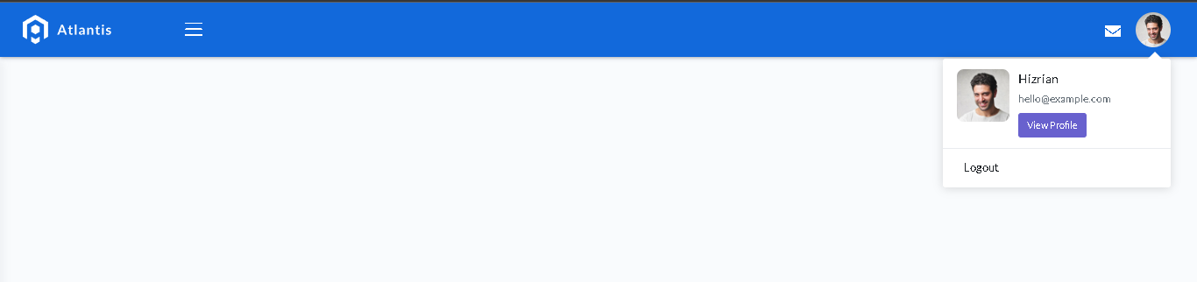

gambar 10

Silahkan tempatkan syntax berikut diantara <div class="sidebar sidebar-style-2"> dan </div>

<div *class*="sidebar-wrapper scrollbar scrollbar-inner">

                <div *class*="sidebar-content">

                    <ul *class*="nav nav-primary">

                        <li *class*="nav-item active">

                            <a *href*="home">

                                <i *class*="icon-layers"></i>

                                <p>Beranda</p>

                            </a>

                        </li>

                        <li *class*="nav-item">

                            <a *href*="#">

                                <i *class*="icon-note"></i>

                                <p>Form</p>

                            </a>

                        </li>

                        <li *class*="nav-item">

                            <a *href*="#">

                                <i *class*="icon-tag"></i>

                                <p>Tentang</p>

                            </a>

                        </li>

                    </ul>

                </div>

            </div>

text box 10

hasil

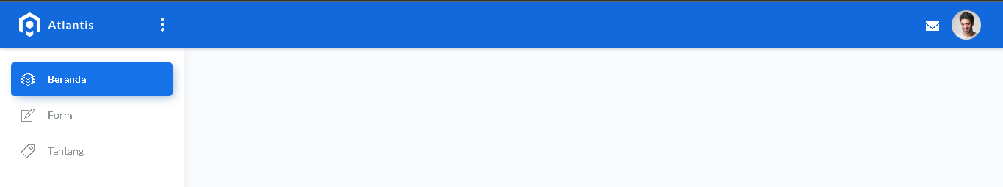

gambar 11

Tempatkan syntax berikut diantara <div class="main-panel"> dan </div>

<div *class*="content">

</div>

Buat file bernama **beranda.php**

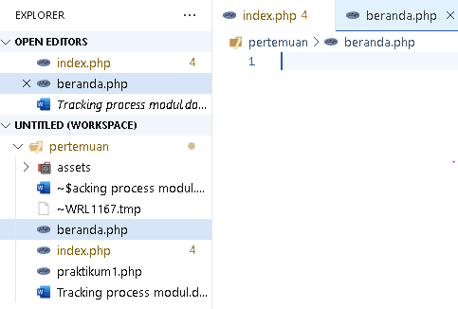

menulis syntax pada file **beranda.php**

<div *class*="panel-header bg-primary-gradient">

    <div *class*="page-inner py-5">

        <div *class*="d-flex align-items-left

align-items-md-center flex-column flex-md-row">

            <div>

                <h2 *class*="text-white pb-2 fw-bold">Beranda</h2>

                <h5 *class*="text-white op-7 mb-2">

Halaman Beranda Informasi Sistem

                </h5>

            </div>

        </div>

    </div>

</div>

text box 11

<div *class*="page-inner mt--5">

..kode belum ada ..

</div>

text box 12

Tempatkan syntax berikut diantara <div *class*="page-inner mt--5">

dan </div>

    <div *class*="row mt--2">

        <div *class*="col-6">

            <div *class*="card card-success">

                <div *class*="card-header">

                    <div *class*="card-title">Data 1</div>

                </div>

                <div *class*="card-body pb-0">

                    <div *class*="mb-4 mt-2">

                        <h1>123456</h1>

                    </div>

                </div>

            </div>

        </div>

        <div *class*="col-6">

            <div *class*="card card-danger">

                <div *class*="card-header">

                    <div *class*="card-title">Data 4</div>

                </div>

                <div *class*="card-body pb-0">

                    <div *class*="mb-4 mt-2">

                        <h1>123456</h1>

                    </div>

                </div>

            </div>

        </div>

    </div>

text box 13

buat file baru Bernama **.htaccess**

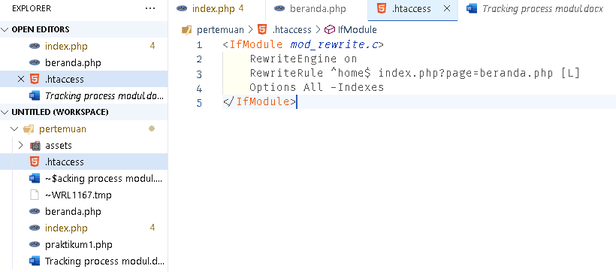

gambar 12

Tulis syntax berikut didalam file **.htaccess**

<IfModule mod_rewrite.c>

RewriteEngine on

RewriteRule ^home$ index.php?page=beranda.php [L]

Options All -Indexes

</IfModule>

text box 14

menulis **syntax PHP untuk menunjang redirect dari mekanisme htaccess**.

<?php error_reporting**(**0**)**;

    $page = htmlentities**(**$_REQUEST**[**'page'**])**;

?>

text box 15

hasil

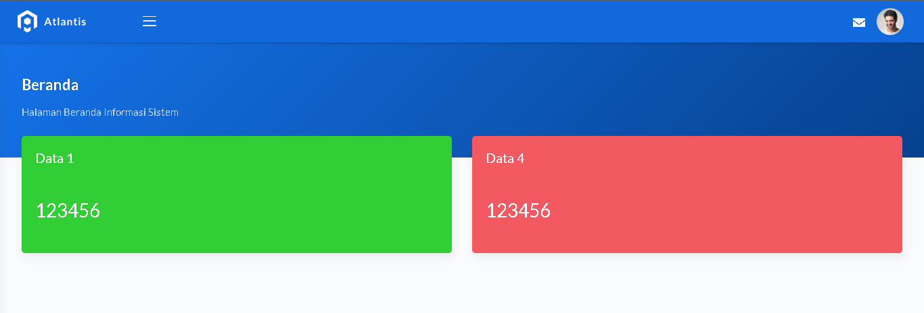

gambar 13